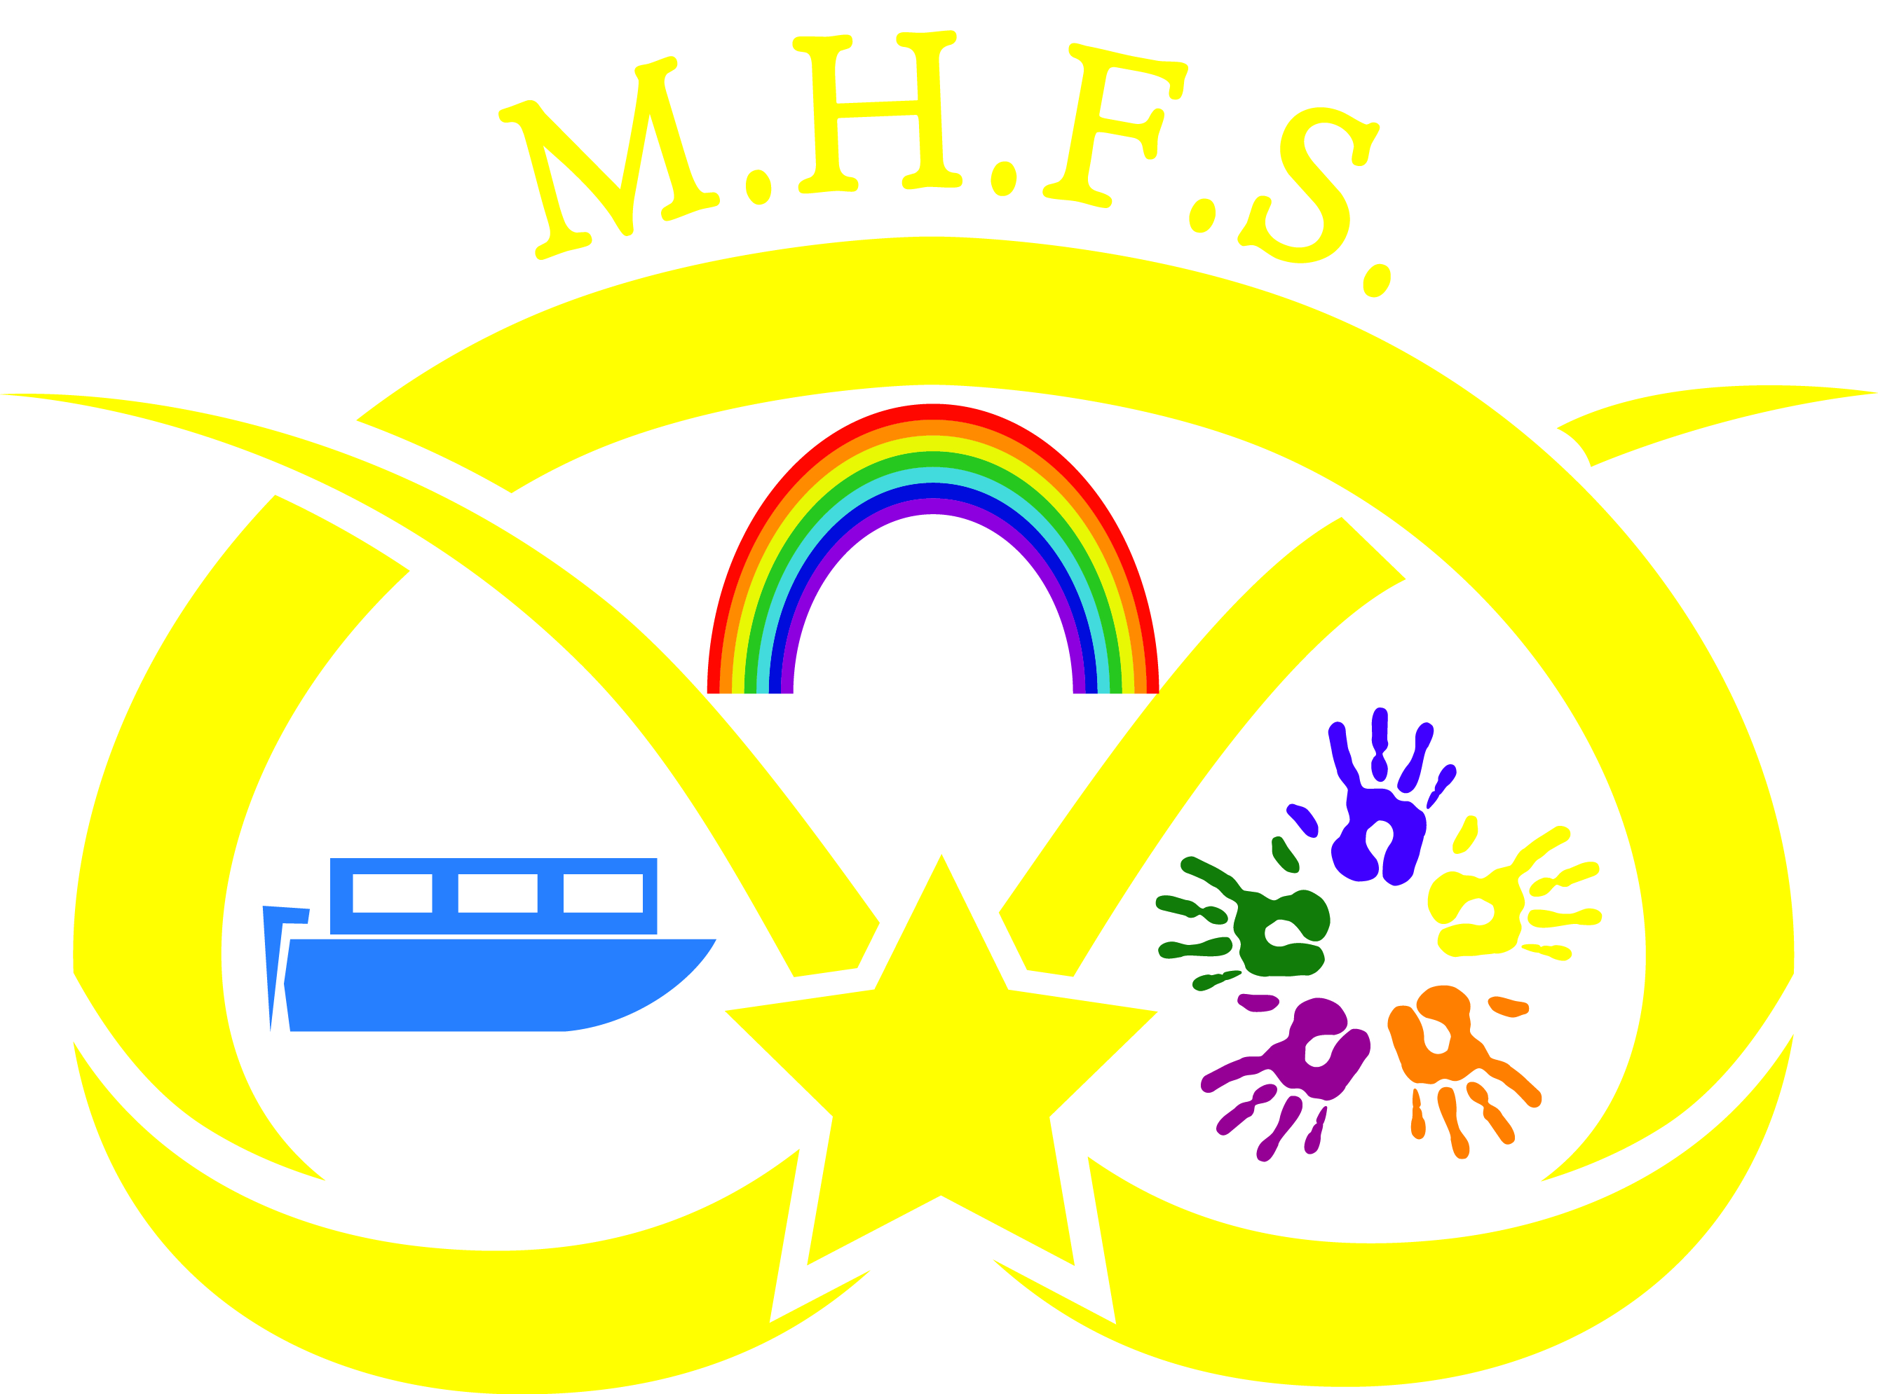
Manor Hill First School
(Forest School) Food Hygiene
To ensure food safety Manor Hill we will -
- make sure food is safe to eat
- make sure you don’t add, remove or treat food in a way that makes it harmful to eat
- make sure the food is the same quality that you say it is
- make sure you don’t mislead people by the way food is labelled, advertised or marketed
- keep records on where you got food from and show this information on demand
- withdraw unsafe food and complete an incident report
- tell people why food has been withdrawn or recalled, for example by using a leaflet or poster
- ensure food allergies and special dietary requirements that are on medical forms are planned for.
Procedures-
- Forest School Leaders and nursery nurses have Training in ‘Food Hygiene in Catering’ at the appropriate level or above
- Training is kept up to date
- Records of incidents kept as required
Agreed November 2022
Review November 2024

